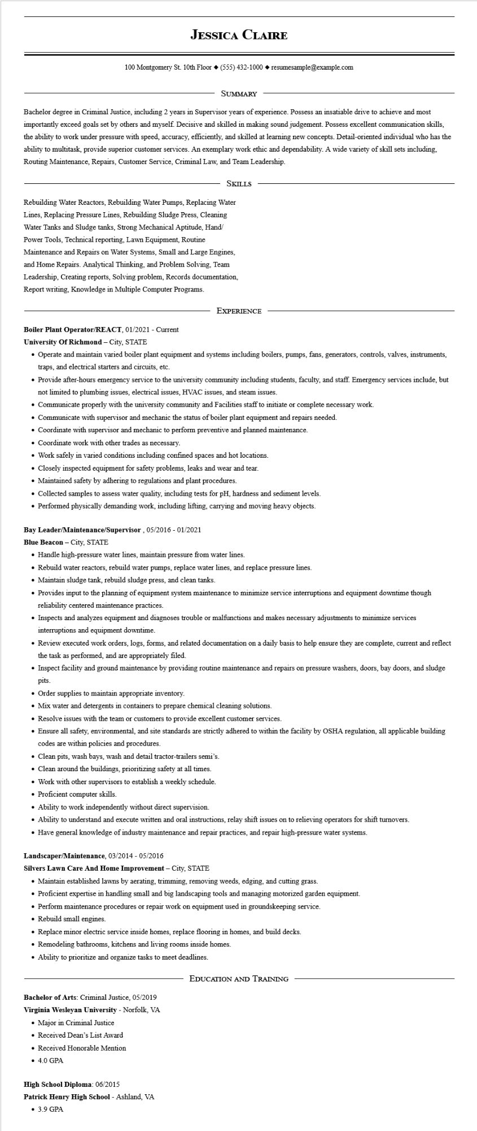
JESSICA CLAIRE
100 Montgomery St. 10th Floor (555) 432-1000◆ resumesample@example.com
SUMMARY
Bachelor degree in Criminal Justice, including 2 years in Supervisor years of experience. Possess an insatiable drive to achieve and most importantly exceed goals set by others and myself. Decisive and skilled in making sound judgement. Possess excellent communication skills, the ability to work under pressure with speed, accuracy, efficiently, and skilled at learning new concepts. Detail-oriented individual who has the ability to multitask, provide superior customer services. An exemplary work ethic and dependability. A wide variety of skill sets including, Routing Maintenance, Repairs, Customer Service, Criminal Law, and Team Leadership.
SKILLS
Rebuilding Water Reactors, Rebuilding Water Pumps, Replacing Water Lines, Replacing Pressure Lines, Rebuilding Sludge Press, Cleaning Water Tanks and Sludge tanks, Strong Mechanical Aptitude, Hand/ Power Tools, Technical reporting, Lawn Equipment, Routine Maintenance and Repairs on Water Systems, Small and Large Engines, and Home Repairs. Analytical Thinking, and Problem Solving, Team Leadership, Creating reports, Solving problem, Records documentation, Report writing, Knowledge in Multiple Computer Programs.
EXPERIENCE
Boiler Plant Operator/REACT, 01/2021 - Current
University of Richmond - City, STATE
• Operate and maintain varied boiler plant equipment and systems including boilers, pumps, fans, generators, controls, valves, instruments, traps, and electrical starters and circuits, etc.
• Provide after-hours emergency service to the university community including students, faculty, and staff. Emergency services include, but not limited to plumbing issues, electrical issues, HVAC issues, and steam issues.
• Communicate properly with the university community and Facilities staff to initiate or complete necessary work.
• Communicate with supervisor and mechanic the status of boiler plant equipment and repairs needed.
• Coordinate with supervisor and mechanic to perform preventive and planned maintenance.
• Coordinate work with other trades as necessary.
• Work safely in varied conditions including confined spaces and hot locations.
• Closely inspected equipment for safety problems, leaks and wear and tear.
• Maintained safety by adhering to regulations and plant procedures.
• Collected samples to assess water quality, including tests for pH, hardness and sediment levels.
• Performed physically demanding work, including lifting, carrying and moving heavy objects.
Bay Leader/Maintenance/Supervisor, 05/2016 - 01/2021
Blue Beacon - City, STATE
• Handle high-pressure water lines, maintain pressure from water lines.
• Rebuild water reactors, rebuild water pumps, replace water lines, and replace pressure lines.
• Maintain sludge tank, rebuild sludge press, and clean tanks.
• Provides input to the planning of equipment system maintenance to minimize service interruptions and equipment downtime though reliability centered maintenance practices.
• Inspects and analyzes equipment and diagnoses trouble or malfunctions and makes necessary adjustments to minimize services interruptions and equipment downtime.
• Review executed work orders, logs, forms, and related documentation on a daily basis to help ensure they are complete, current and reflect the task as performed, and are appropriately filed.
• Inspect facility and ground maintenance by providing routine maintenance and repairs on pressure washers, doors, bay doors, and sludge pits.
• Order supplies to maintain appropriate inventory.
• Mix water and detergents in containers to prepare chemical cleaning solutions.
• Resolve issues with the team or customers to provide excellent customer services.
• Ensure all safety, environmental, and site standards are strictly adhered to within the facility by OSHA regulation, all applicable building codes are within policies and procedures.
• Clean pits, wash bays, wash and detail tractor-trailers semi's.
• Clean around the buildings, prioritizing safety at all times.
• Work with other supervisors to establish a weekly schedule.
• Proficient computer skills.
• Ability to work independently without direct supervision.
• Ability to understand and execute written and oral instructions, relay shift issues on to relieving operators for shift turnovers.
• Have general knowledge of industry maintenance and repair practices, and repair high-pressure water systems.
Landscaper/Maintenance, 03/2014 - 05/2016
Silvers Lawn Care And Home Improvement - City, STATE
• Maintain established lawns by aerating, trimming, removing weeds, edging, and cutting grass.
• Proficient expertise in handling small and big landscaping tools and managing motorized garden equipment.
• Perform maintenance procedures or repair work on equipment used in groundskeeping service.
• Rebuild small engines.
• Replace minor electric service inside homes, replace flooring in homes, and build decks.
• Remodeling bathrooms, kitchens and living rooms inside homes.
• Ability to prioritize and organize tasks to meet deadlines.
Bachelor of Arts: Criminal Justice, 05/2019
Virginia Wesleyan University - Norfolk, VA
• Major in Criminal Justice
• Received Dean's List Award
• Received Honorable Mention
• 4.0 GPA
High School Diploma: 06/2015
Patrick Henry High School - Ashland, VA • 3.9 GPA
EDUCATION AND TRAINING

